

Milena Sahni

**2018**

**Skryne Hill Preschool**

*Building Web Page from the scratch based on Facebook social media account*

# About company

Company name is Skryne Hill Preschool. Skryne Hill Prechool is an existing business and the name was already provided.

Skryne Hill Preschool offers free preschool places (3 hours per day, 5 days per week, 38 weeks of the year) for children aged between 2 years 8 months and 6 years eligible for the ECCE scheme.

# Hosting & Domain

I chose domain name skrynehillpreschool.ie which is hosted by Blacknight and costs 4.99 € per year.

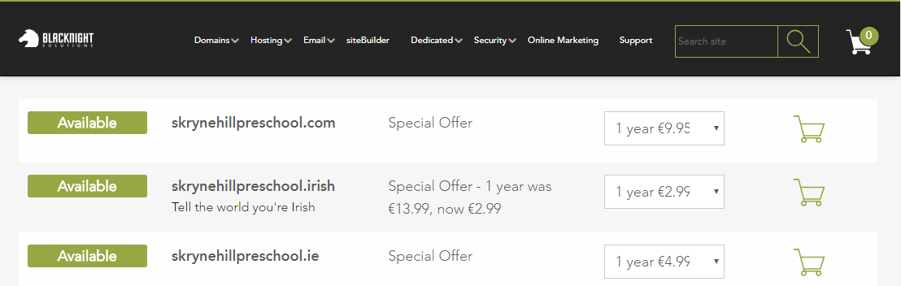

# Goals & Objectives

Effectively advertise the services to ensure business fills in its available places. Enforce online presence and provide all necessary information to public.

# Target Audience

Parents and families in local area

# Site structure

C:\Users\dweb17\Downloads\Untitled Diagram (6).png

# Wireframes

Mobile HOME PAGE

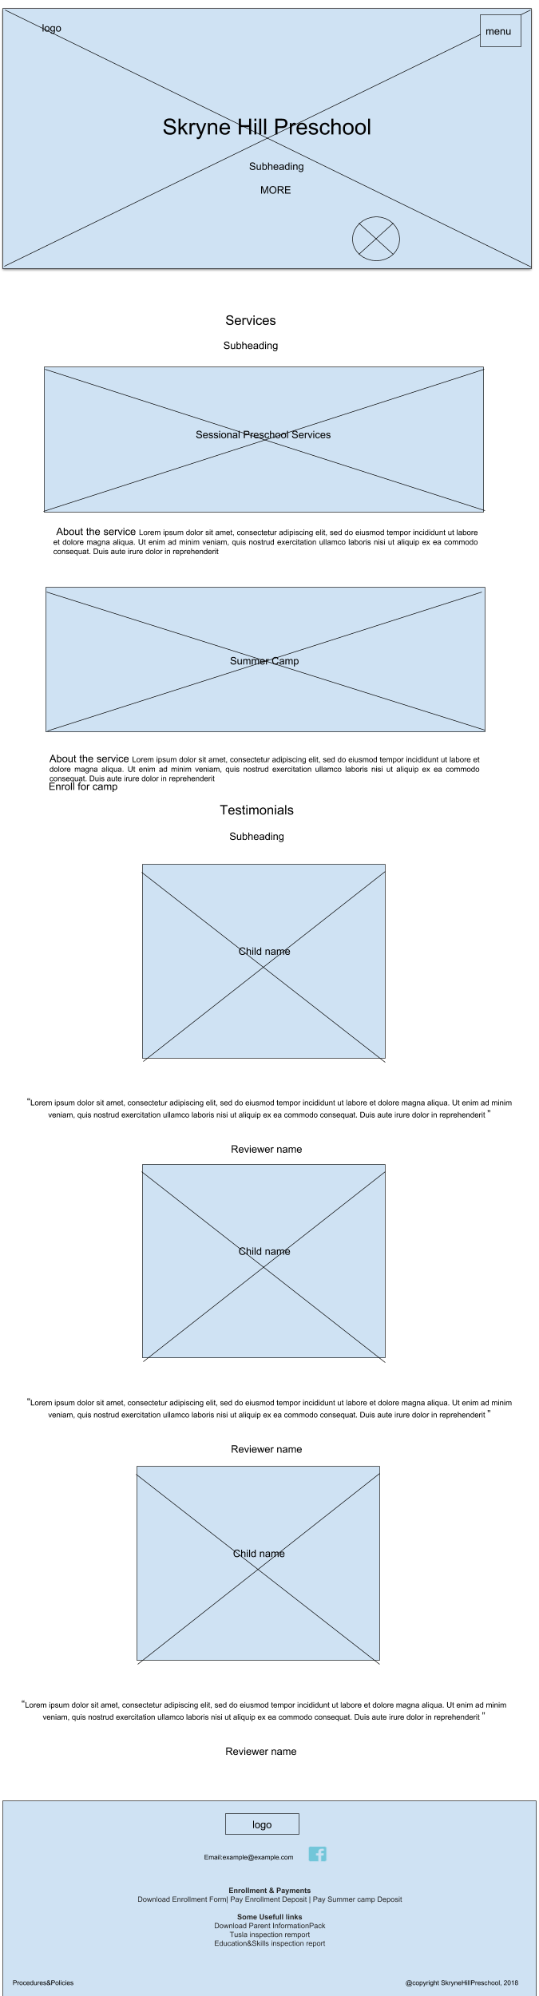

Mobile ABOUT PAGE

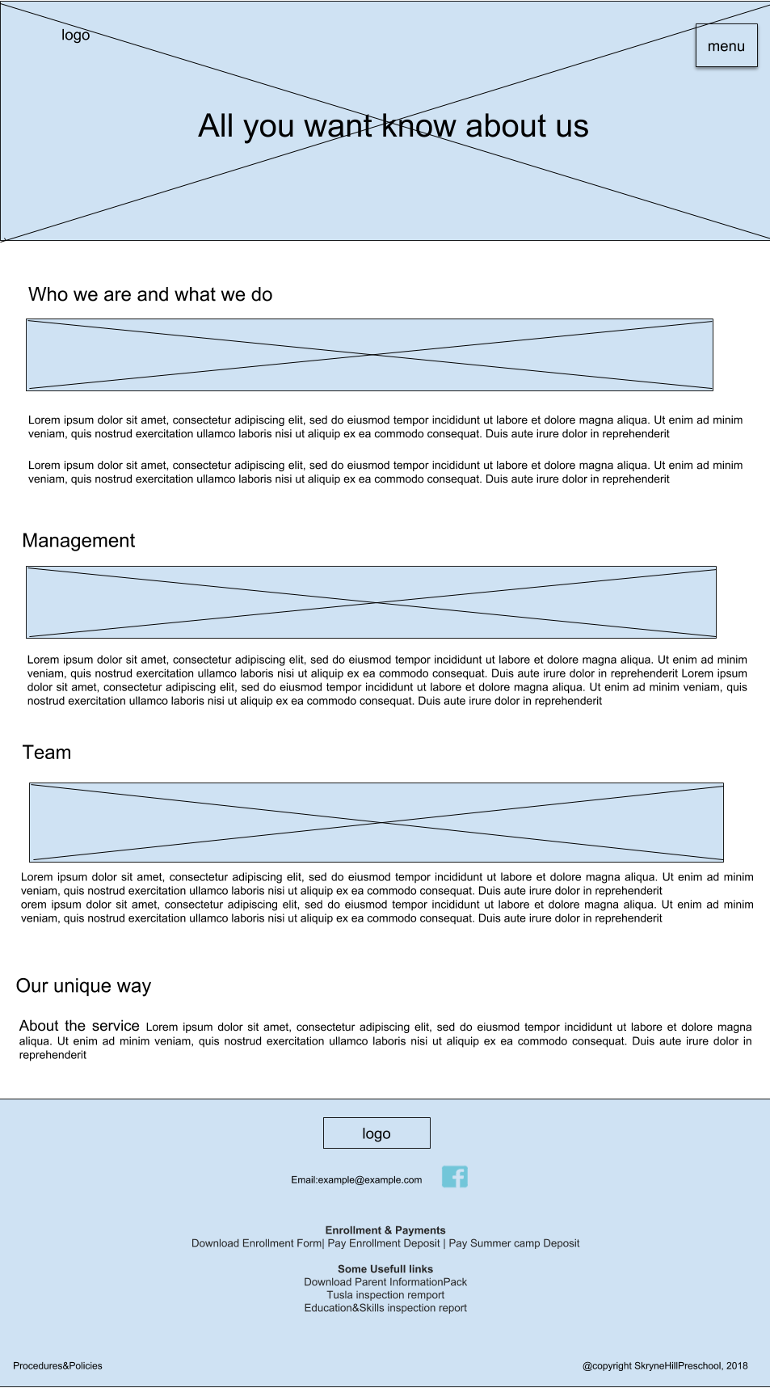

Mobile SUMMER CAMP PAGE

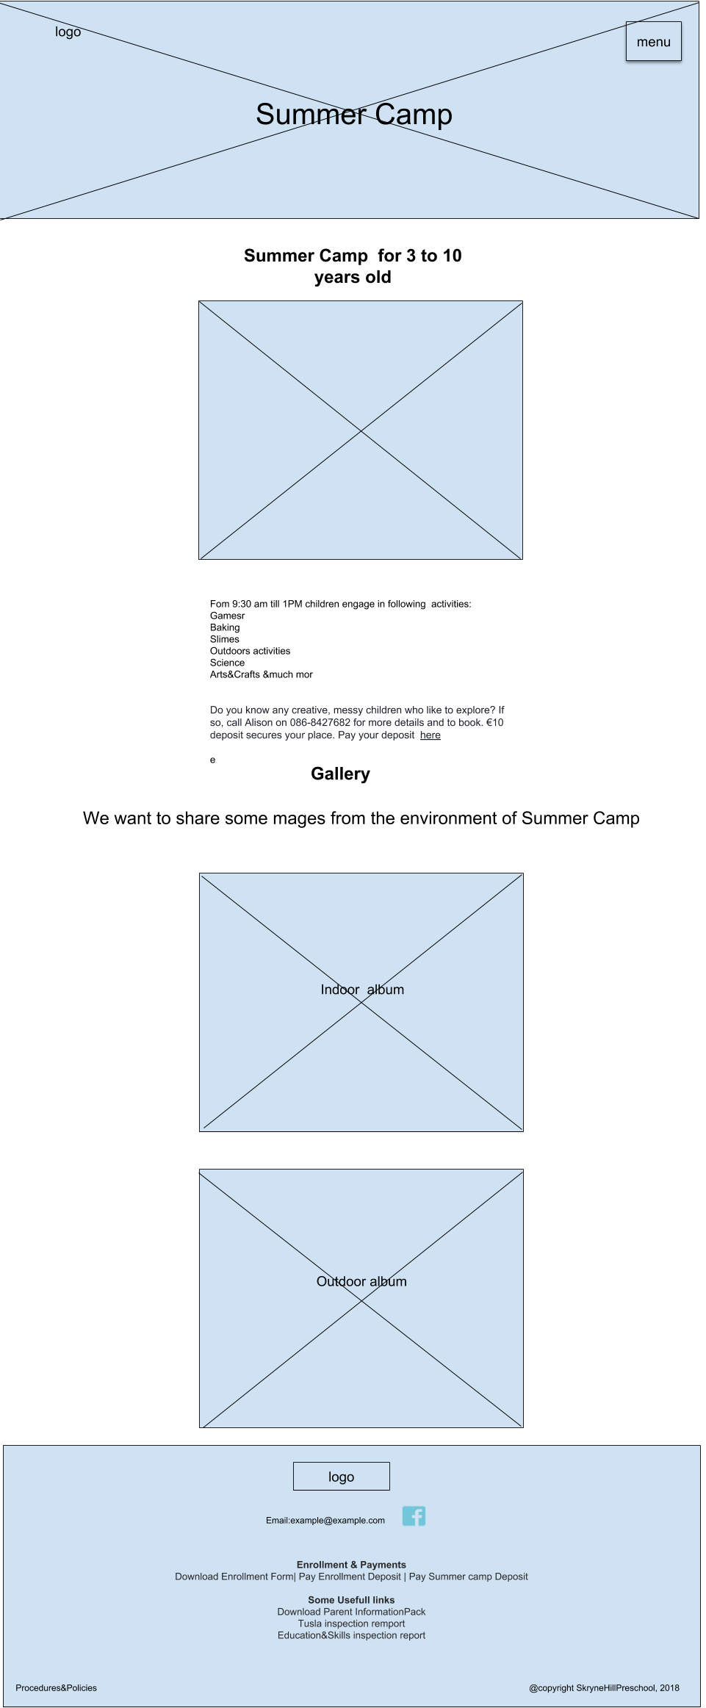

Mobile SESSIONAL SERVICES PAGE

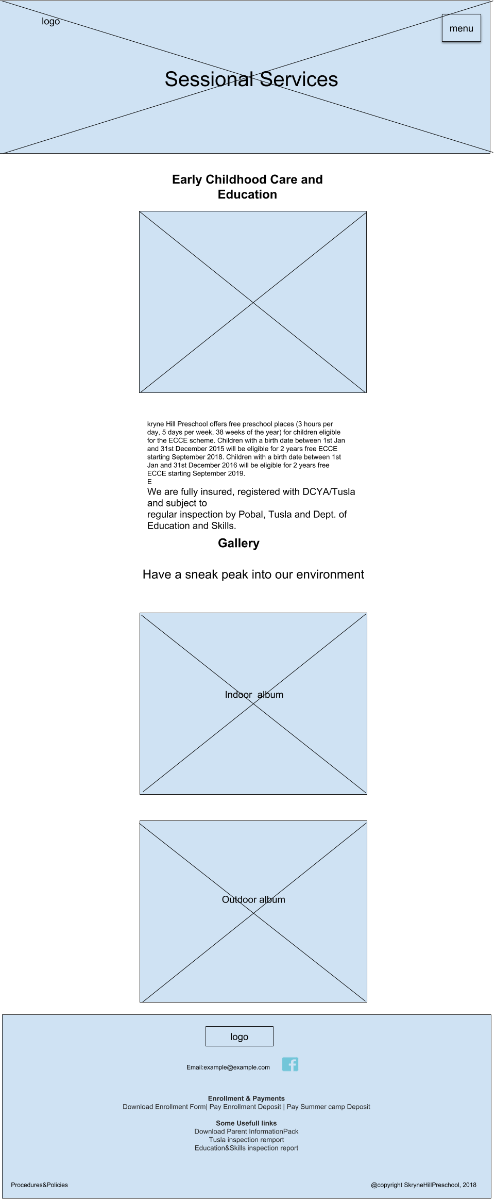

Mobile CONTACT PAGE

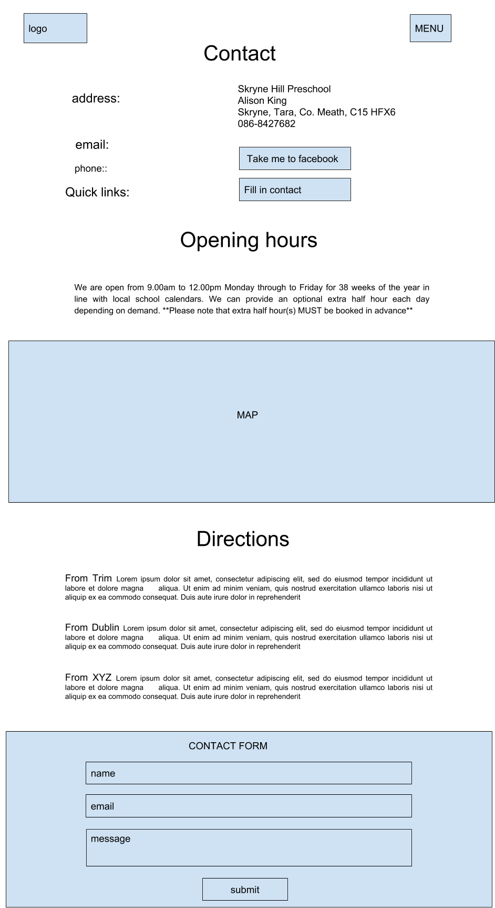

Desktop HOME PAGE

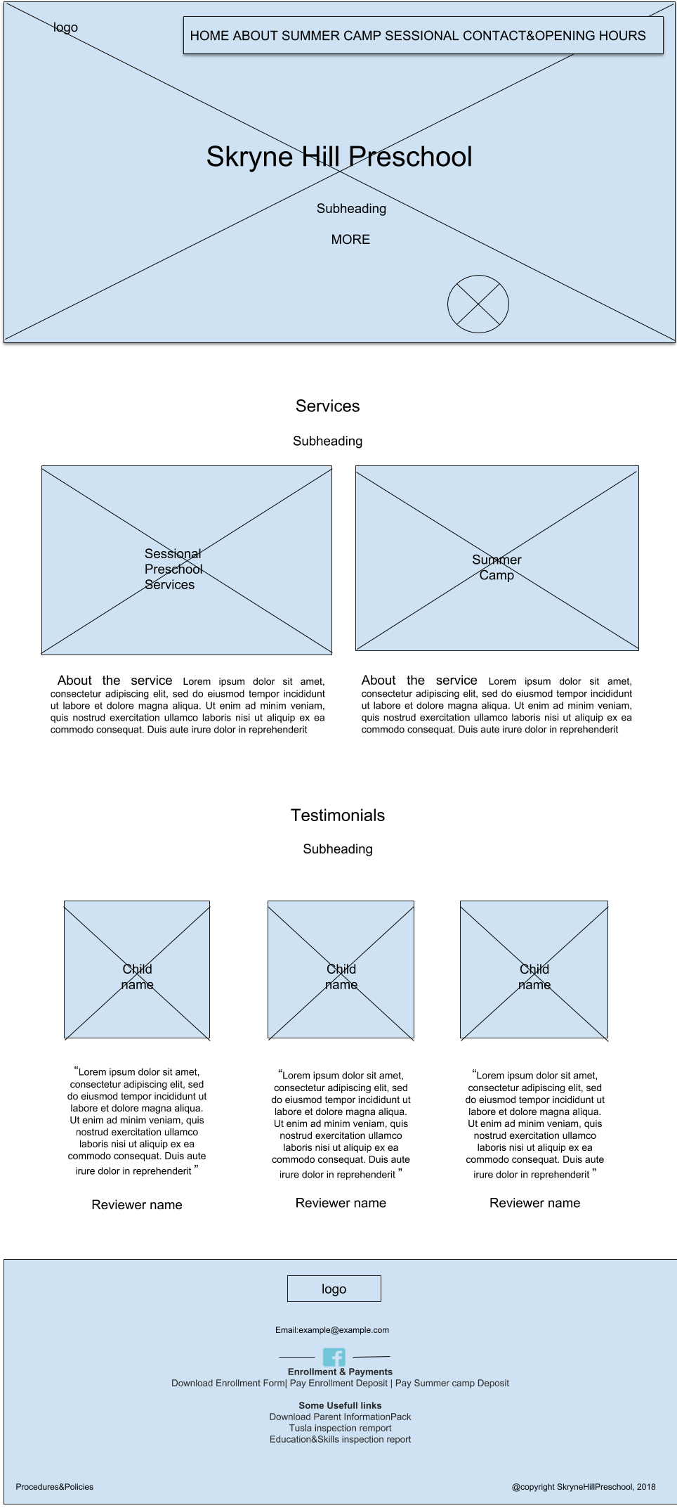

Desktop ABOUT PAGE

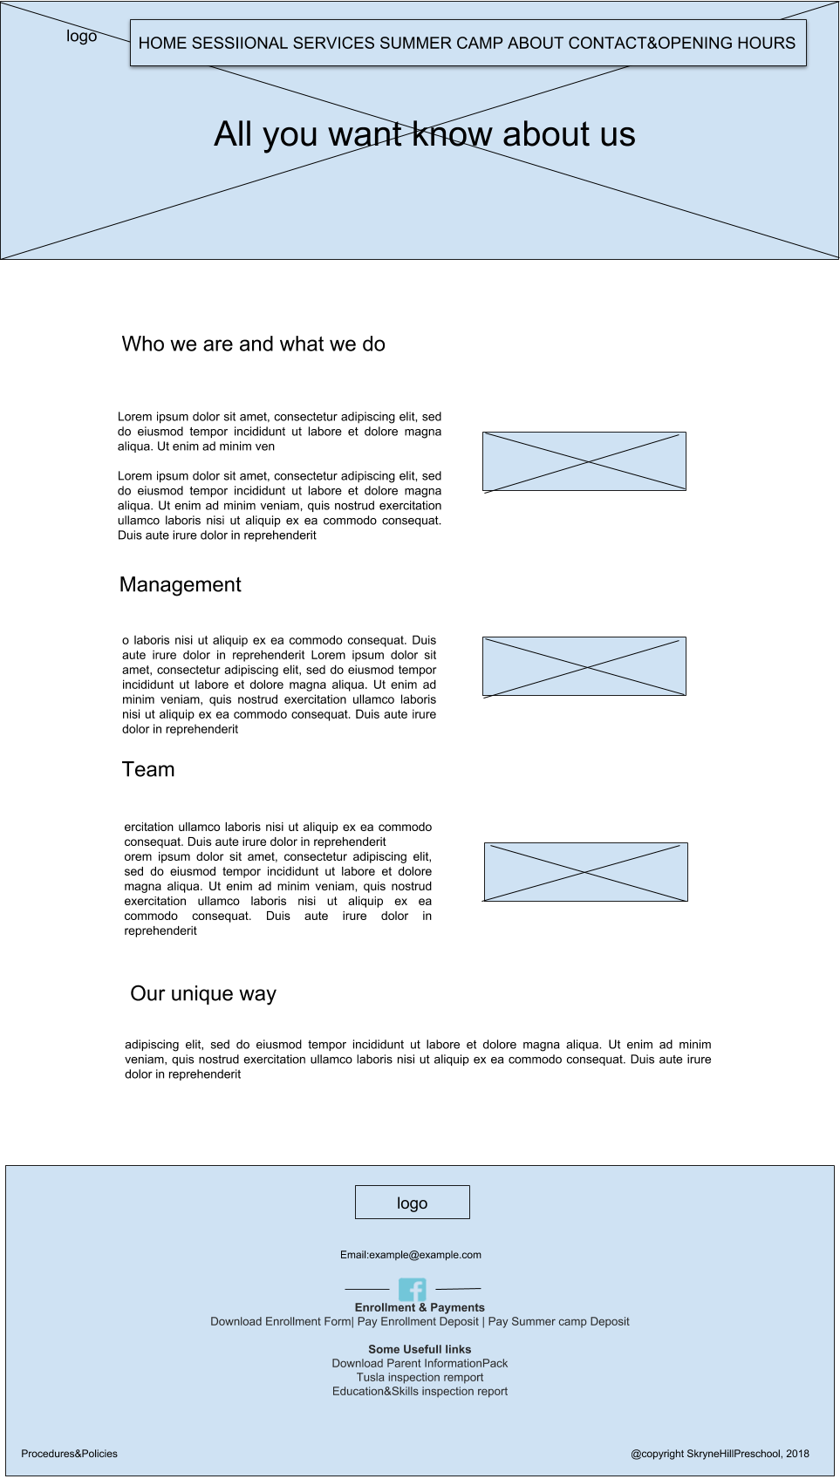

Desktop SUMMER CAMP PAGE

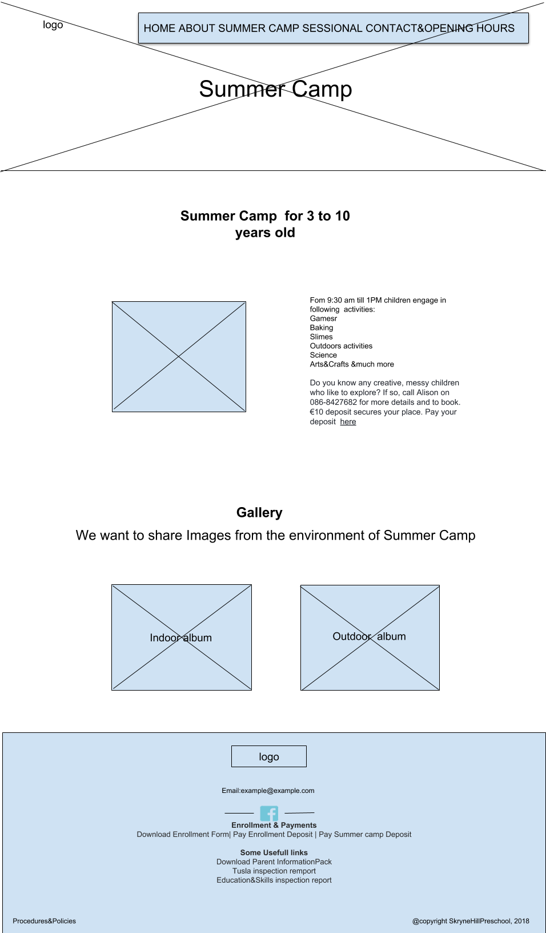

Desktop SESSIONAL SERVICES PAGE

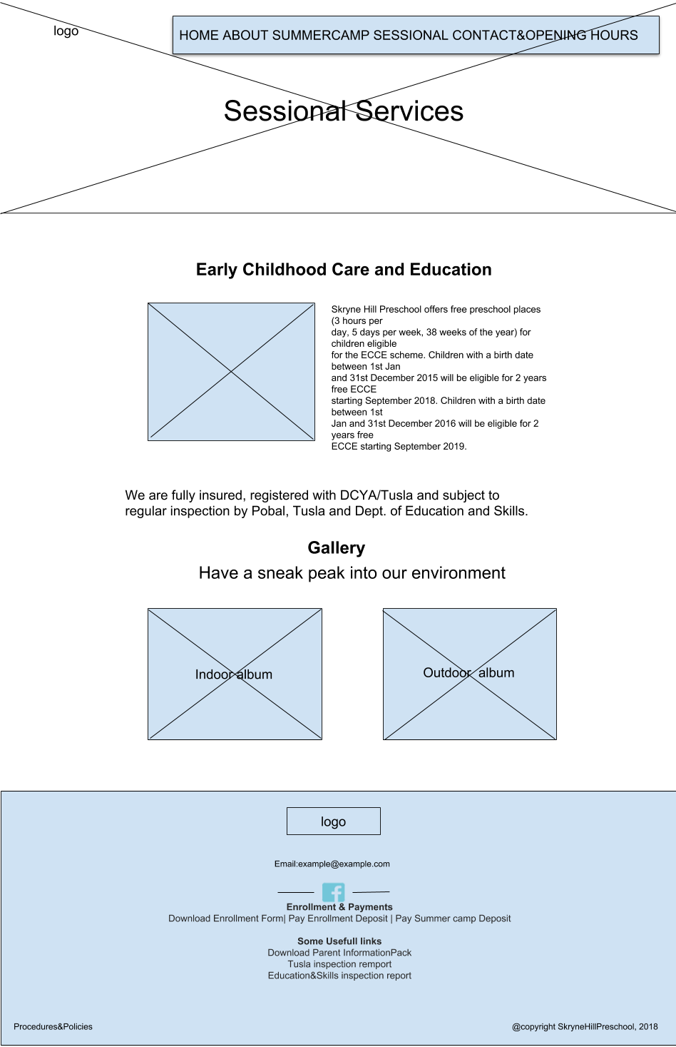

Desktop CONTACT &OPENING HOURS PAGE

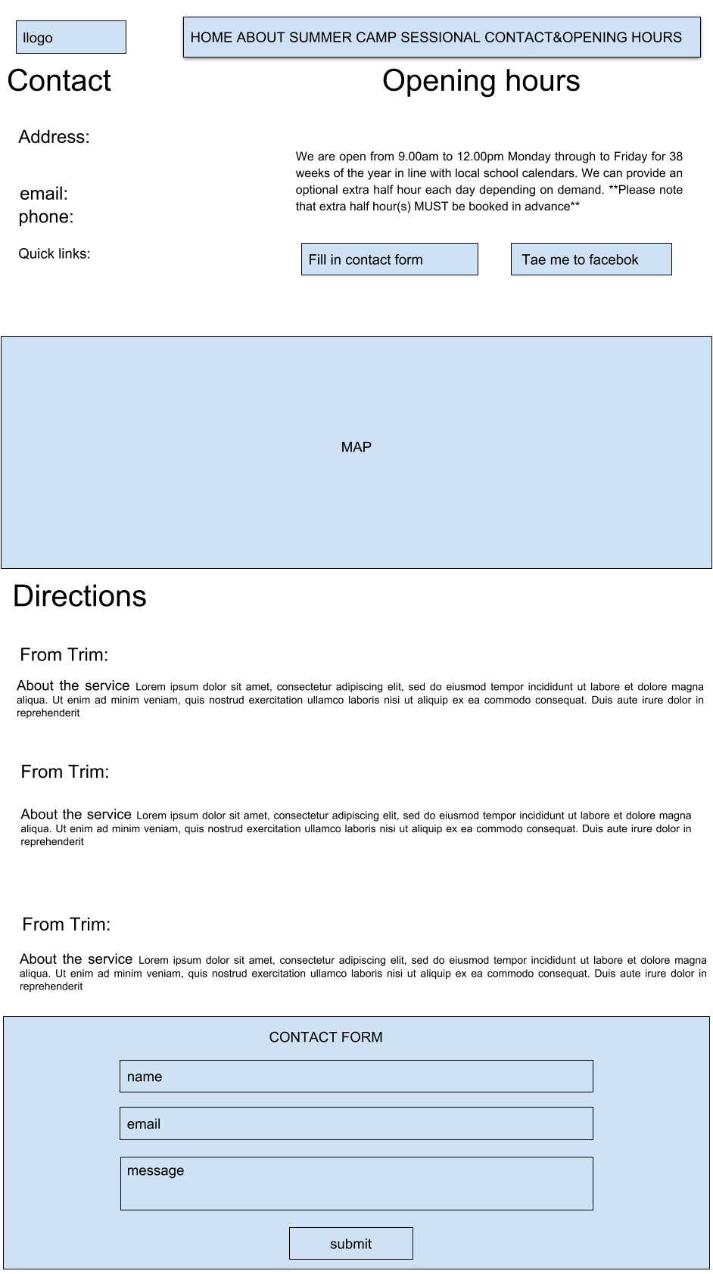

# Content on Pages

**Home Page**

**Skryne Hill Preschool**

*A beautiful, purpose-built preschool located in an idyllic rural setting on the historic Hill of Skryne*

Tell me more

**Services**

*In our Preschool we offer following services*

ECCE Sessional Service - We operate a sessional pre-school service for 38 weeks of the year under the ECCE Scheme. We can cater for up to 22 children from the age of 2.8 to 6 years. We have three qualified and experienced staff members. We operate an emergent, play-based curriculum with Reggio Emilia, High Scope and Montessori influences.

Summer Camp – We operate a creative and messy Summer Camp for 4 weeks throughout July and August. We can cater for up to 11 children from the age of 3 to 10 years.

**Testimonials**

*About us written by happy parents:*

“My child smile like that because of SkryneHill Preschool ”

Full name of reviewer

**About Page**

*All you want to know about us*

**Who we are and what we do**

Skryne Hill Preschool is a beautiful, purpose-built preschool located in an idyllic rural setting on the historic Hill of Skryne which opened in September 2015. We aim to actively promote the holistic development of children by providing a safe, secure and developmentally appropriate environment. Our preschool is a spacious and bright room with double doors that open out into our outdoor space to encourage the children to take an interest in the world outside. Our fully enclosed large outdoor natural play area is used by children daily as part of their play and learning development. The environments within the preschool invite children to explore and to see a world of possibilities that are within their reach.

We provide a developmentally appropriate, child-led emergent curriculum, both indoors and outdoors, through inspiring resources and experiences. Our curriculum supports children’s Well-being, Identity & Belonging, Communication, and Exploring & Thinking following Aistear, Ireland’s Early Childhood Curriculum Framework. Our older children are encouraged to get “Ready for School” so they can approach school with self-help skills and confidence that will enable them to succeed.

**Management**

Alison King is the owner/manager of Skryne Hill Preschool and holds qualifications in Early Childhood Care and Education at FETAC Level 5 and 6 as well as a Degree in Art, Design, Mixed Media and Textile Design. With over 15 years’ experience working in the Early Years sector, Alison is also a Healthy Ireland Smart Start trainer with the National Childhood Network working with and mentoring preschools throughout Meath and Louth.

**Team**

Our team of fully qualified and caring staff are trained in first aid, are Garda vetted and their references are rigorously checked before recruitment. We ensure adult child ratios are maintained as recommended by Tusla, ensuring each child receives the care and attention that they need. We are inspected and approved by Tusla, the Department of Education and Skills, and Pobal. We are members of Early Childhood Ireland and are fully insured.

**Our unique ways**

We are committed to offering a preschool that is engaging, inclusive, welcoming and respectful of the input of the parents. We operate an Open Door Policy for parents.

**Sessional Services**

**Early Childhood Care and Education**

Skryne Hill Preschool offers free preschool places (3 hours perday, 5 days per week, 38 weeks of the year) for children eligiblefor the ECCE scheme. Children with a birth date between 1st Janand 31st December 2015 will be eligible for 2 years free ECCEstarting September 2018. Children with a birth date between 1stJan and 31st December 2016 will be eligible for 2 years freeECCE starting September 2019.

We are fully insured, registered with DCYA/Tusla and subject toregular inspection by Pobal, Tusla and Dept. of Education and Skills.

**Gallery**

Have a sneak peek into our environment

**Summer Camp**

**Summer Camp  for 3 to 10 years old**

From 9:30 am till 1PM children engage in following  activities:

Games

Baking  
Slimes

Outdoors activities

Science

Arts&Crafts &much more

Do you know any creative, messy children who like to explore? If so, call Alison on 086-8427682 for more details and to book. €10 deposit secures your place. Pay your deposit  here

**Gallery**

We want to share Images from the environment of Summer Camp

**Contact &Opening Hours**

Skryne Hill Preschool

Alison King

Skryne, Tara, Co. Meath, C15 HFX6

086-8427682

[skrynehillpreschool@gmail.com](mailto:skrynehillpreschool@gmail.com)

<https://www.facebook.com/skrynehillpreschool/>

*Opening Hours:*

We are open from 9.00am to 12.00pm Monday through to Friday for 38 weeks of the year in line with local school calendars. We can provide an optional extra half hour each day depending on demand. **Please note that extra half hour(s) MUST be booked in advance**

Directions from Navan: Get on the R147 heading towards Dublin. Continue on this road (through three roundabouts) for about 11km. Take a left at Ross Cross for Skryne. Continue on the Old Ross Road until you come to the next crossroads at Swan’s Pub. Take a left here and then take the next left at the Priest’s Cross. Skryne Hill Preschool is directly behind the 7th house on the right.

Directions from Trim: Take the R154 headed towards Dublin/Clonee. After 10km turn left toward Knightsfield Park. Continue straight onto Knightsfield Park. Continue onto Old Ross Road. Turn left onto R147 and then take the immediate right for Skryne onto Old Ross Road. Continue on the Old Ross Road until you come to the next crossroads at Swan’s Pub. Take a left here and then take the next left at the Priest’s Cross. Skryne Hill Preschool is directly behind the 7th house on the right.

Directions from Dublin: Take the M3 (this road is tolled) headed for Cavan. At junction 6, take the R125 exit to Dunshaughlin/Trim. At the roundabout, take the 3rd exit onto R125. At the roundabout, take the 1st exit and stay on R125. At the roundabout, take the 1st exit onto R147. At Ross Cross turn right for Skryne onto Old Ross Road. Continue on the Old Ross Road until you come to the next crossroads at Swan’s Pub. Take a left here and then take the next left at the Priest’s Cross. Skryne Hill Preschool is directly behind the 7th house on the right.

Directions via M1 Motorway or Drogheda: Take the M1 (this road is tolled) coming from Belfast. At junction 7, take the R132 exit to Julianstown/Balbriggan (North). At the roundabout, take the 1st exit onto R132. Turn left onto R150. Turn right onto R150/R152. Take the 1st left onto R150. Turn left onto N2. Turn right onto R153. Turn left for the road towards Trim. Continue until you come to the crossroads at Swan’s Pub. Take a right here and then take the next left at the Priest’s Cross. Skryne Hill Preschool is directly behind the 7th house on the right.

**Footer links**

Link to download our policies and procedures

Download Parent Information Pack and Enrolment form

Link to latest Tusla inspection report on Tusla website

Link to Dept, of Education and Skills inspection report on DES website

Link to pay enrolment deposit

Contact us form

Link to pay summer camp deposit

**Images**

File sizes between 30KB and 40KB , big banner images 140KB

Images cropped for 200 by 200 for testimonials and 300 by 200 for gallery. All other images are background images

***Home Page Images***



**elfbutterfly.png**sourced from pngtree.com   
file size: 120KB, dimensions: 200px × 149px



**logo.png**

sourced from Facebook account  
file size:8KB dimensions:100px×52px



**welcome.jpg**  
sourced from Facebook account  
file size:23KB dimensions:200px × 200px

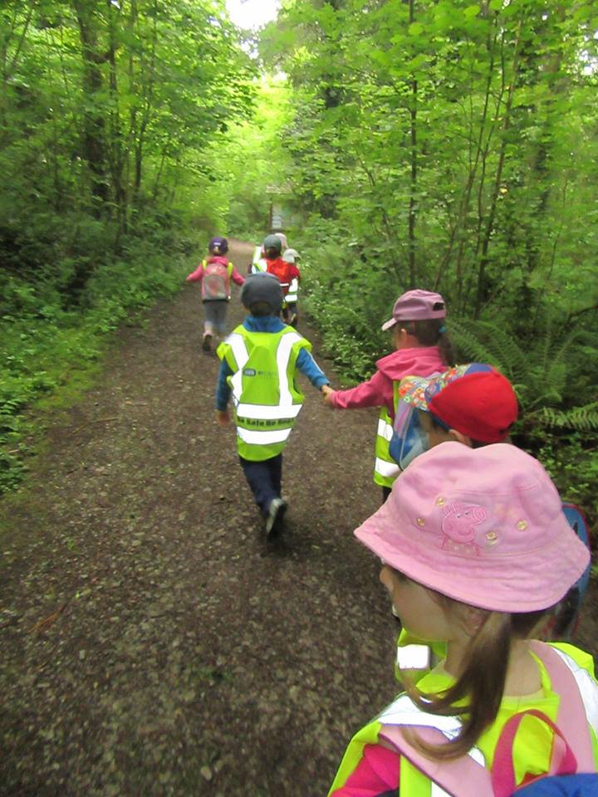

**banner.jpg**  
sourced from Facebook account  
file size:143KB dimensions:899px × 466px

***Home Page Services section Images***

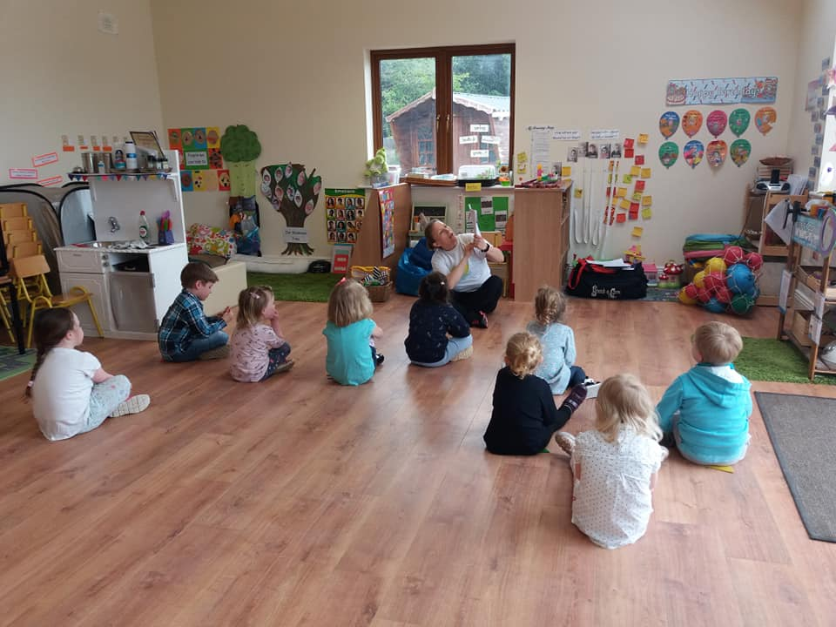 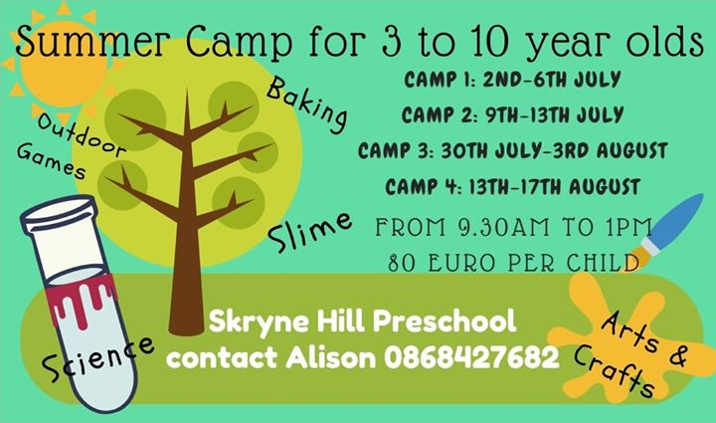

**sessionalservices.jpg summercampservices.jpg**  
sourced from Facebook account sourced from Facebook account  
file size:32KB dimensions:298px × 201px file size:35KB dimensions:340px × 200px  
background image background image

***Home Page Testimonials section Images***

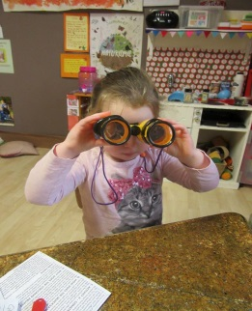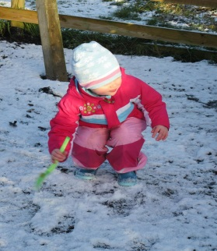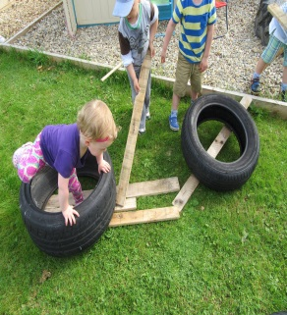

**happychild1.jpg happychild2.jpg happychild2.jpg**   
sourced from Facebook sourced from Facebook sourced from Facebook  
 account account account  
file size:26KB dimensions: file size:29KB dimensions: file size:27KB dimensions:  
199px × 201px 299px × 203px 202px × 199px

 

**pinkbg.jpg happychild2.jpg yellowbg.jpg**   
sourced from pexels.com sourced from pexels.com sourced from pexels.com   
file size:15KB dimensions: file size:18KB dimensions: file size:13KB dimensions:  
300px × 199px 300px × 168px 300px × 200px

***About Page Images***

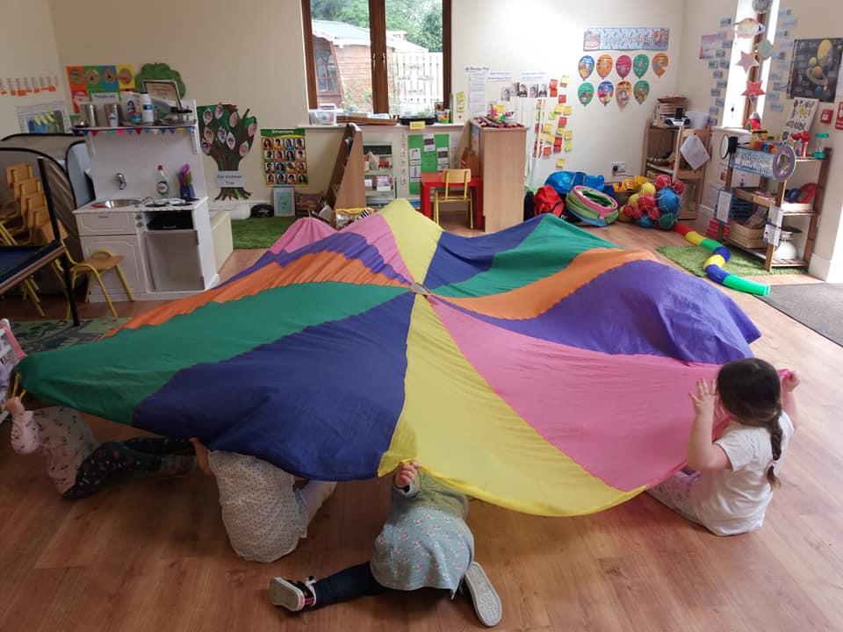

**bannerabout.jpg**  
sourced from Facebook account  
file size:131KB dimensions:898px × 493px  
background image

***Gallery Page Images & Multimedia***

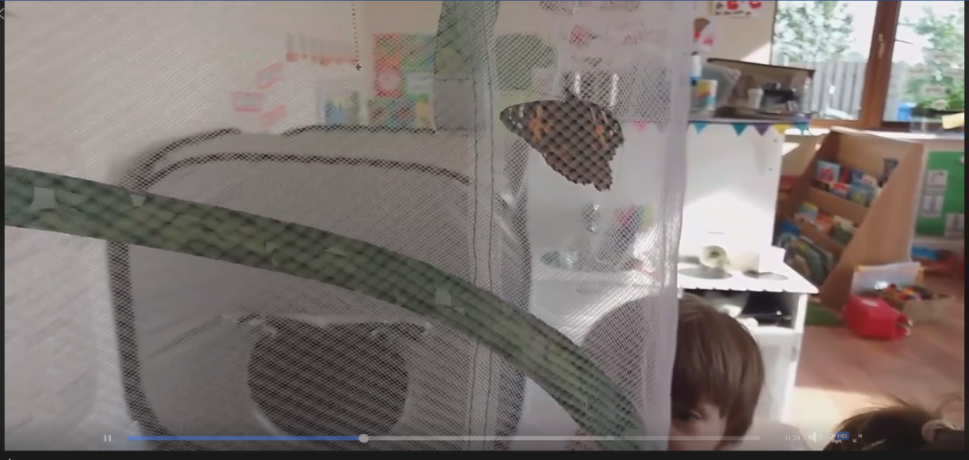

Butterfliesvideo

***Sessional Page Images***

***Sessional Services Page Gallery section Images***

Sourced from Facebook dimensions 300px × 200px  
File size cca 30-40KB

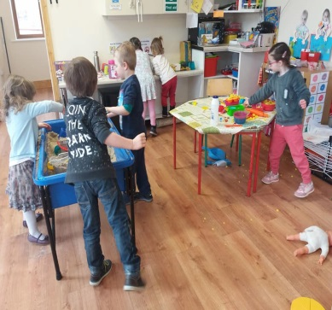 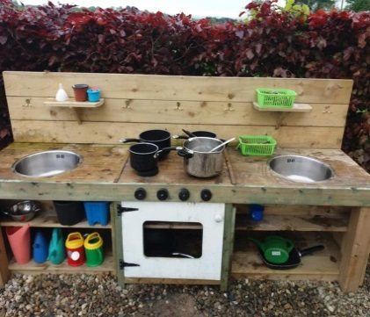 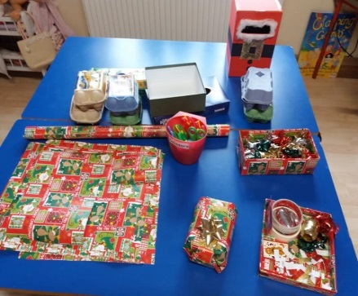

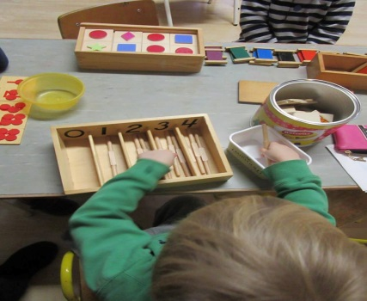 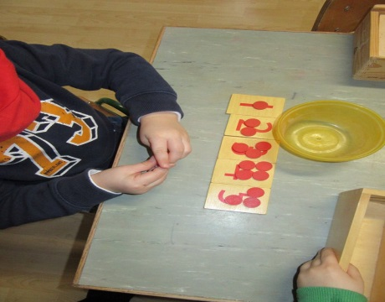

***Summer Camp Page Images***

***Summer Camp Page Gallery section Images***

Sourced from Facebook dimensions 300px × 200px  
File size cca 30-40KB

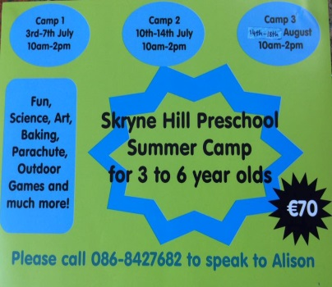

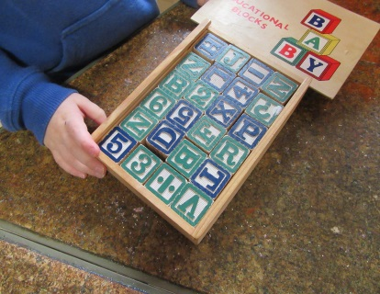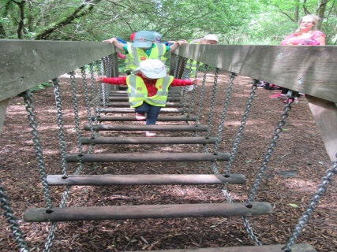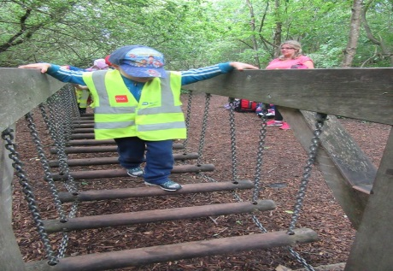

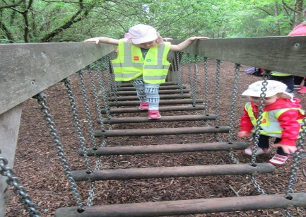

# Colors

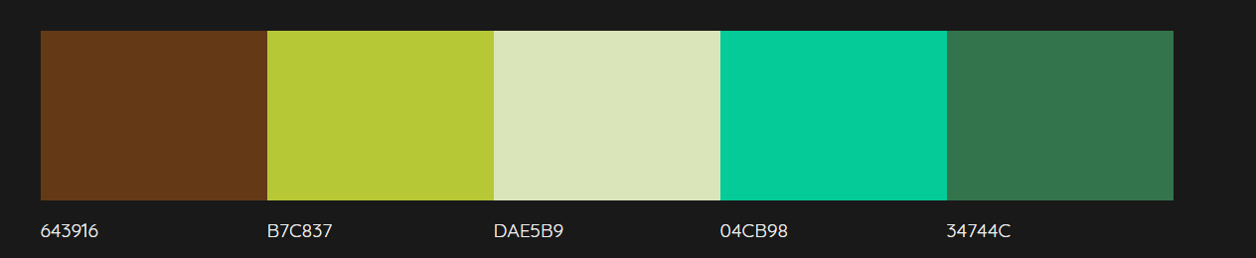

Also might use some of these colours some of these range

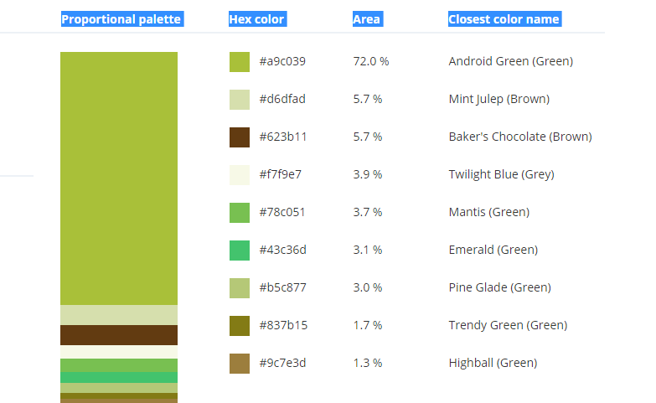

Top of Form

Bottom of Form

Font specimen sheet  
**Size, colors, type and location**

font-family: 'Playfair Display', serif;font-family: 'Lato', sans-serif; font-family: 'Roboto', sans-serif;

<link href="https://fonts.googleapis.com/css?family=**Lato|Playfair+Display|Roboto**" rel="stylesheet">

Body text: #000;

Heading in body: #664013 Dark Brown or #9bb840 Android Green (Green)

Text with background: #f4f7e1 Promenade (White) or #664013 Dark Brown

Navigation font size: 0.875em

Heading1 large desktop size: 5em on tablet 3em on mobile 2em

Heading2 large desktop size: 3em , medium and tablets 2em , mobile 1.2em

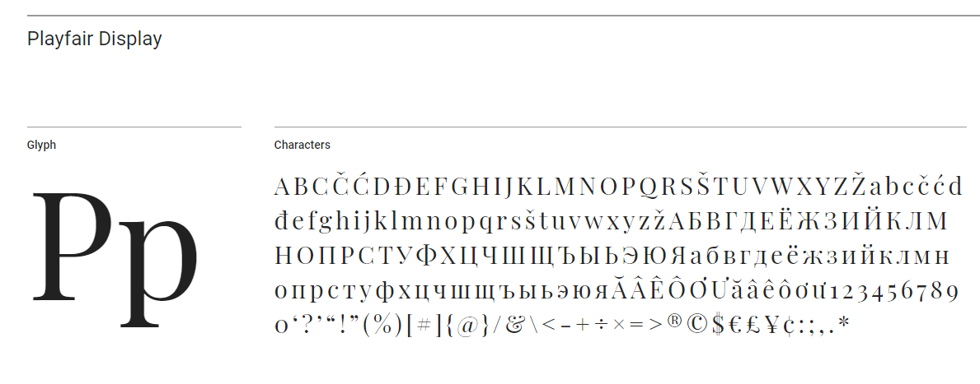

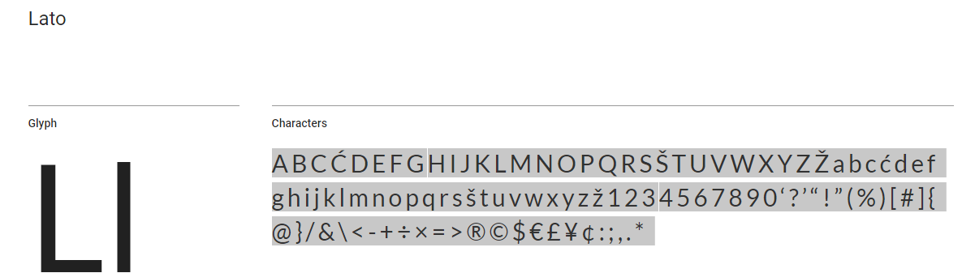

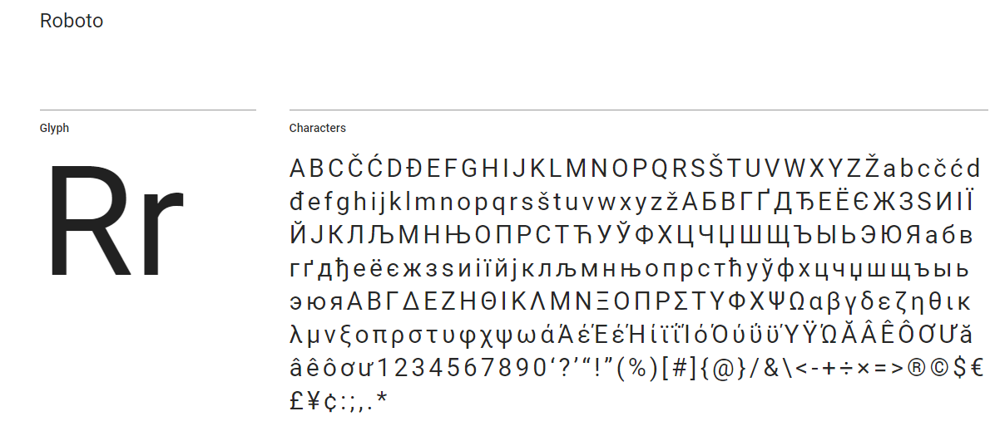

# Height and width specs

All banners across desktop and mobile images full width

**Mobile widths**

*Home:*Container mobile for main content 90%

Images per Services and all text: 100% of container

Images for Testimonials: 50% of container

*About:* Container 100% width with some padding

*Summer Camp&Sessional:* Full widths container with some padding for text and images

*Contact:* Container with 90% width

**Desktop widths**

*Home:*Container for main content 80%

Images and text of services 45% of container width

Images and text of Testimonials: 30% of container width

*About:* Container 80% ,Images and text 45% width

*Sessional & Summer camp:* Container: 80%

Images of 45% width of container.

*Contact:* Container with 90% width

2 column layout for Contact info and opening hours: 30% and 70%

# Accessibility features

I plan to make effort on building accessibility features along the way. Content will make sense and will be ordered in way, that it makes sense also without stylesheet. I will use contrasting colours for headings for text to reads well and will use appropriate sizes on mobile and desktop. HTML elements will be using tags with semantic meaning where appropriate ie for grouping web page sections and its headings. Images will use descriptive alt tags except decorative images. Form will use labels, error messages will be placed correctly and emphasized, so they can catch user’s attention. I will make use of fieldset tag and legend tag to group form fields.

# Initial search engine strategy

**Title and meta description and content**

Initial strategy is to include highly relevant well thought keywords. Using h1 and h2 tags to list primary keywords within the content and h3 and h4 tags for listing any secondary keywords. Keywords placement must make sense in context.

Title tag is what will be displayed by Google. Therefore title must be a primary keyword. My title tag is less then 60 character to avoid truncated

I will add descriptive and engaging meta description. Content is great way to rank for tailed keyword. So if there is a rich content page can rank well because of it’s content too.

**URLs**

I will use URLS , which makes sense , so user can comprehend what the content of it might be.URLs will not include underscores, spaces, or any other characters to separate words. I will use lower case letters

**Key words**

*Keywords home:*

Skryne Hill Preschool, Kids Summer Camp , Children Summer Camp , ECCE eligible ,Services, happy parents, testimonials ECCE, Childcare

*Keywords about:*

Skryne Hill Preschool, Management, Team, Open door policy, children’s Well-being

*Keywords Sessional Services:*

Skryne Hill Preschool, ECCE scheme, Free Preschool places, Gallery, Preschool Childecare indoor, Childcare outdoor ,Early Childhood Care and Education

*Keywords Summer Camp:*

Skryne Hill Preschool, Gallery, Preschool environment, Summer Camp, Childecare indoor, Childcare outdoor, Games, Baking, Slimes, Outdoors activities, Arts&Crafts

*Keywords contact:*

Skryne Hill Preschool, email, phone, address, contact ,opening hours, contact form, facebook

**Pages Title and Meta Descriptions**

|  |  |  |  |
| --- | --- | --- | --- |
| Page | Title | Description | Character count |
|  |  |  |  |
| Home Page | Skryne Hill Preschool –located in an idyllic rural setting | Skryne Hill Preschool offers Summer Camp for children and we operate a sessional service under the ECCE Scheme. Have a look what happy parents have to say and our services. | Title:59char, Description:  172 char |
| About Page | Skryne Hill Preschool –located in an idyllic rural setting | Skryne Hill Preschool is great place for Children’s well-beings. Read more about our team, management, open door policy | Title:59char, Description:  119 char |
| Summer Camp Page | Skryne Hill Preschool –located in an idyllic rural setting | Do you know any creative, messy children who like to explore? Book our summer for 3 to 10 years old. Browse gallery of summer camp. | Title:59char, Description:  131 char |
| Sessional Services Page | Skryne Hill Preschool –located in an idyllic rural setting | Skryne Hill Preschool offers free preschool places for children eligible  for the ECCE scheme. Have a sneak peek in our Gallery of our environment | Title:59char, Description:  146 char |
|  |  |  |  |
| Contact Page | Skryne Hill Preschool –located in an idyllic rural setting | Skryne Hill Contact information including address email phone number , opening hours Facebook and quick contact form | Title:59char, Description:  118 char |

# Project timetable

|  |  |  |  |
| --- | --- | --- | --- |
| Dates | Page section develop | Area of focus | Animation , JavaScript or other Features |
|  |  |  |  |
| **12/06/2018** | Home Section About Page  Summer Camp Page | Pages fully finished for mobile, navigation, logo and Intro text | Includes script for changing navigation color on scroll an mobile menu, smooth scroll script |
| **13/6/2018** | Sessional Services About Page Contact Page | Pages fully finished for mobile | Plugin for Gallery  Include map and validation, script for form animation |
| **14/06/2018** | Home Section About Page  Summer Camp Page | Pages fully finished for Desktop | Any outstanding scripts |
| **15/06/2018** | Sessional Services About Page Contact Page | Pages fully finished for Desktop. | Any outstanding scripts |
| **18/06/2018** | Tidy up and review |  |  |
| **19/06/2018** | Usability tests |  |  |

Contents

About company 1

Hosting & Domain 1

Goals & Objectives 1

Target Audience 1

Site structure 2

Wireframes 3

Content on Pages 13

**Home Page** 13

**Images** 16

Colors 23

Font specimen sheet 24

Height and width specs 25

Accessibility features 26

Initial search engine strategy 27

**Title and meta description and content** 27

**URLs** 27

**Key words** 27

**Pages Title and Meta Descriptions** 28

Project timetable 29